CHE507 ADVANCED PROCESS CONTROL
FINAL EXAM

Professor Shi-Shang Jang 12/30/99

Problem #1 (25%)
Vapor feed to an adiabatic tubular reactor is heated to about 700°F in a furnace. The reaction is endothermic. The exit temperature of gas leaving the reactor is to be controlled at 600°F.
Draw an instrumentation and control diagram that accomplishes the following objectives:
- Feed is flow-controlled.
- Fuel gas is flow-controlled and ratioed to feed rate.
- The fuel to feed ratio is adjusted by furnace exit temperature controlled by a reactor exit temperature controller.
- The set point of the furnace exit temperature controller is adjusted by reactor exit temperature controller.
- Furnace exit temperature is not to exceed 750°F.
- High furnace stack-gas temperature should pinch the fuel gas control valve.

Problem #2 (25%)
Air and water streams are fed into a pressurized tank through two control valves. Air flows out of the top of the tank through a restriction, and water flows out the bottom through another restriction. The linearizied equations describing the system are
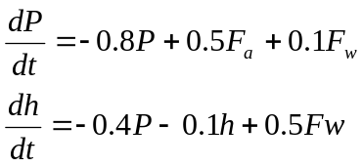
where P= pressure
h= liquid height
F_{a}= air flow rate into tank
F_{w}= water flow rate into tank
Use state variable methods to calculate:
- The open loop eigenvalues and the open loop transfer function matrix.
- Calculate the RGA, what is the suitable pairing for two SISO controller?
- Design a decoupling algorithm for this system.

Problem #3 (25%)
Derive a pulse transfer function (z-domain) for the following plants with a zero order hold and a sampling time of 1:
- 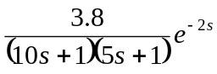 (10 points)
- 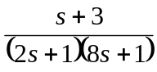 (10 points)
- 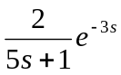 (5 points)

Problem #4 (25%)
Consider an IMC closed loop system with a model transfer M(s), controller transfer I(s) and plant transfer function P(s) , show that:
- The system is input-output stable if the model is perfect and open stable.
- The system is perfect controlled if the model is perfect and invertibale.
- The system has zero offset if 